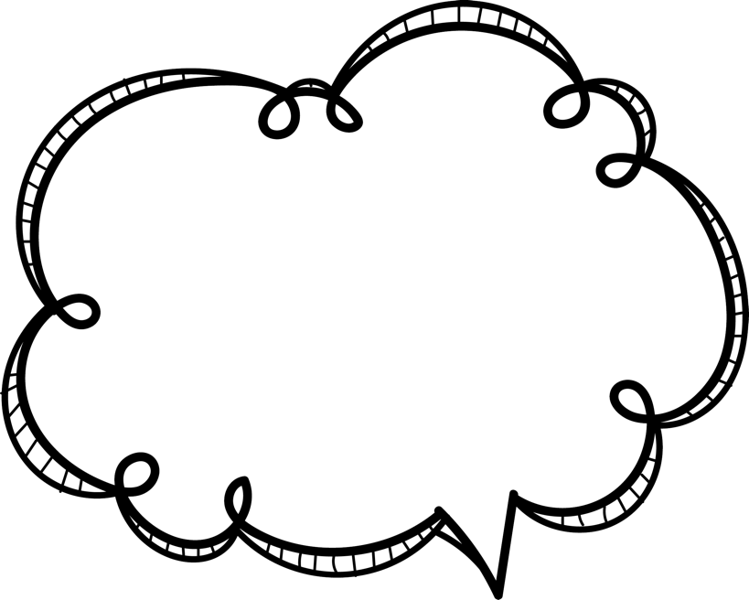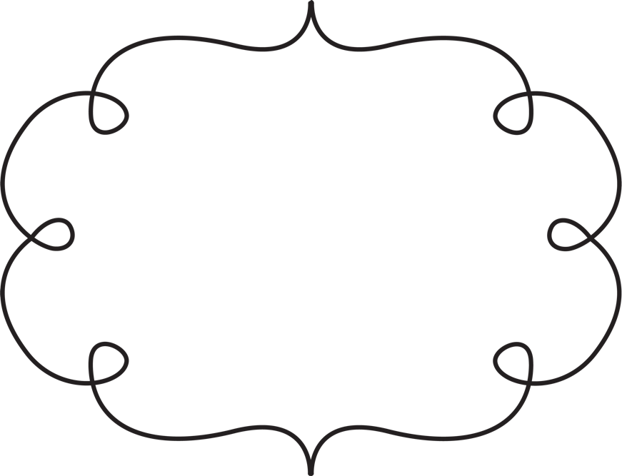

**Jenny Mullins**

**Library**

**I want my classroom**

**parents to know..**

**I am so thankful for our generous parents**

**and grandparent volunteers!**

**Favorites**

**Sports team: Astros**

**Color: Purple or Turquoise**

**Fruit: Apples - Honeycrisp or Pink Lady**

**Candy: Snickers**

**Gum flavor: Bubble or Smooth Mint**

**Soft drink: Gingerale**

**Sonic drink: Cherry Limeade**

**Starbucks drink: Javachip Frappuccino Half caffine**

**Cookie: Chocolate Chip**

**Nothing Bundt Cake: Any**

**Dessert: Brownies**

**Take out restaurant: Chick Fil-A**

**Sit down restaurant: Pappas**

**Ice cream shop/flavor: Dairy Queen - Snickers Blizzard**

**Coffee shop: Starbucks  
Bookstore: Amazon**

**Teacher supply store: Amazon**

**Flower: Rose**

**Scent: Lavendar - any relaxing**

**Nail salon: Texas Nail Bar**

**Hobby: Working out**

**Birthday: March 26th**

**T-shirt size: X Large**

**Monogram: Mrs. Mullins**

**Dietary restrictions: None**

**Classroom parents can help**

**me most by...**

**Volunteer in the library :)**

**If I were given a gift card, I’d love it to be for...**

**Any place on wish list! I like Beyond Beaute' Spa in Clear Lake**